Ten Prophetic Clues Concerning
Dan – the Irish

There is not much direct history connecting the tribe of Dan to the Irish people. We are talking about one of the lost tribes. Even the Caucasian population of Ireland comes from various backgrounds. One can compare this to Jewry. The Jewish people have known many proselytes, yet, there has been a core of the tribe of Judah (and some of Levi & Benjamin) over the past 2500 years. The core passes on characteristics and genes to the periphery. Looking at the ‘prophetic clues’, one has to conclude, that a core of the tribe of Dan once found its way to Ireland. This core passed its characteristics and genes onto the influx of others. The more fulfilled prophetic clues we find, the stronger our case. What follows is not historic proof, but proof by revelation.

1st Clue: Father Dan: Ancestor Don

47 And the coast of the children of Dan went out too little for them: therefore the children of Dan went up to fight against Leshem, and took it, and smote it with the edge of the sword, and possessed it, and dwelt therein, and called Leshem, DAN, AFTER THE NAME OF DAN THEIR FATHER. 48 This is the inheritance of the tribe of the children of Dan according to their families, these cities with their villages (Joshua 19:47-48, AV, unless mentioned otherwise).
And they called the name of the city Dan, AFTER THE NAME OF DAN THEIR FATHER, who was born unto Israel: howbeit the name of the city was Laish at the first (Judges 18:29).

The 12 Patriarchs

And He gave him the covenant of circumcision: and so Abraham begat Isaac, and circumcised him the 8th day; and Isaac begat Jacob; and Jacob begat the 12 patriarchs (Acts 7:8).
The phrase ‘Dan their father’ appears twice in scripture. The Danites were very proud of their forefather, of their ancestor. The names of the other 11 patriarchs do not appear in scripture with ‘father’. Neither did the descendants of the other 11 tribes name cities after their ancestors.

The Irish & Don

Wikipedia, Donn: “In Irish mythology, Donn ... is an ancestor of the Gaels and is believed to have been a god of the dead. Donn is said to dwell in Tech Duinn ..., where the souls of the dead gather. ... A 9th-century poem says that Donn's dying wish was that all his descendants would gather at Tech Duinn after death: "To me, to my house, you shall all come after your deaths". ... and Harry Roe commented that "to go to the House of Donn in Irish tradition means to die". This suggests that the pagan Gaels saw Donn as their ancestor and believed they would go to his abode when they died. ... The Christian writers who recorded the Lebor Gabála Érenn made Donn into Éber Donn one of the mythical Milesian ancestors of the Gaels. The Milesians invade Ireland and take it from the Tuatha Dé Danann [Tribe of the Danites in Hebrew: Sheveth haDani]. ...”.
The Danites had their forefather Dan and the Irish have their forefather Don.
The term ‘father’ has some significance as well. The 5 Danites on their way to Leshem say to the young Levite, Micha’s priest: “And they said unto him, Hold thy peace, lay thine hand upon thy mouth, and go with us, and be to us a father and a priest: is it better for thee to be a priest unto the house of one man, or that thou be a priest unto a tribe and a family in Israel?” (Judges 18:19).
“Father” is a common address to Roman Catholic priests by the Irish.

2nd Clue: Dan: serpent on the way

... and dwelt therein, AND CALLED LESHEM, DAN, AFTER THE NAME OF DAN THEIR FATHER. (Joshua 19:47).
And the spirit of the Lord first came on [Samson] him in MAHANEH-DAN, between Zorah and Eshtaol (Judges 13:25, BBE).
And they [600 Danites] went up, and pitched in Kirjathjearim, in Judah: WHEREFORE THEY CALLED THAT PLACE MAHANEH-DAN unto this day: behold, it is behind Kirjathjearim (Judges 18:12).
AND THEY CALLED THE NAME OF THE CITY DAN, AFTER THE NAME OF DAN THEIR FATHER, who was born unto Israel: howbeit the name of the city was Laish at the first (Judges 18:29).
Then they came to Gilead, and to the land of Tahtimhodshi; AND THEY CAME TO DAN-JAAN, ... (2Sam 24:6).
Dan shall be A SERPENT BY THE WAY ... (Gen 49:17a).


Snake trail in the sand

The trail of Dan

Danites named towns and rivers after their forefather Dan (Josh 17:49; Judg 18:29). These verses give three clues. Firstly, Dan is the forefather of the Danites and Don is the ancestor of the Irish. Secondly, Dun- has become fort or settlement in Celtic languages and can be found back in many toponyms in Great Britain and Ireland. Thirdly, it also gives us the trail of Dan – Dan is like a serpent – right through Europe, to the British isles. Dan is like the trail of a serpent.

Nachal Dan & Yarden (Jordan)

In Israel there is the brook Dan (Nachal Dan) and also the river Jordan (Yarden). According to some Yarden comes from ‘yared Dan’, ‘descending from Dan’.

Don, Dnjepr, Dnjestr, Danube

When the Celts (Ten Tribes) trekked through Europe, the names of many rivers changed (Danube used to be Ister).
Dan left a trail of names behind: Danube, Dunaj, Dzvina, Don, Donets, Dnjepr, Dnjestr, Dysna, Tana, Dantzig and Danmark.
Some believe the Danes in Danmark to be Danites, but it is more likely that the Danites just passed this place. The Danes (Vikings) did not spread toponyms with the prefixes Dun-, Don- or Dan-, neither in their own country, nor in the rest of Scandinavia.
The trail leads to the British and Irish isles, and from there to the rest of the Anglo-Saxon world (i.e. Australia & Canada).
Big and small rivers with the names Don and Tyne: The river Don is a river in Russia; Don (Vilaine), a river in Brittany; River Don, Lancashire, England; River Don, Tyne and Wear, England; River Don, Yorkshire, England; Little Don River, England; River Don, Aberdeenshire, Scotland; Don River (Ontario), Canada; Don River (Central Queensland), Australia; Don River (North Queensland), Australia; Don River (Tasmania); Don River (Victoria), Australia.
Rivers on maps look like wriggling snakes or serpents.

Dun-, Din-, Don- in Ireland

In Ireland we find the biggest concentration of toponyms with Dun-, Don-, Doon- or Din-.
Hereby a list of Irish towns or villages beginning with Dun-, Don-, Doon- or Din- :
Daingean, Deansgrange, Dingle, Donabate, Donaghmede, Donaghmore, Donegal, Doneraile, Donnybrook, Donnycarney, Doon (Limerick), Doon (Offaly), Doonaha, Doonbeg, Dooniver (Dún Ibhir), Downings (Na Dúnaibh), Dunboyne, Duncannon, Duncormick, Dundalk, Dunderrow, Dundrum (Dublin), Dundrum (Tipperary), Dunfanaghy, Dungarvan (Waterford), Dungarvan (Kilkenny), Dungloe (an Clochán Liath), Dungourney, Dunkineely, Dún Laoghaire, Dunlavin, Dunleer, Dunmanway, Dunmore, Dunmore East, Dunquin (Dún Chaoin), Dunshaughlin.
We do not find toponyms with Dun-, Don-, Doon- or Din- in Denmark.

Dun: Fort – Settlement - Town

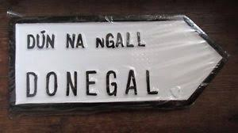
The Danites called their new settlements Dan. Most likely it became the name for a settlement, (hill)fort, village or town, in general. Towns are fortified villages and fortresses often became towns. It is very likely that the toponym Dan of the Danites became the hillfort Dun of the Celts.

3rd Clue: Dan: anger, temper

10 And the son of an Israelitish woman, whose father was an Egyptian, went out among the children of Israel: and this son of the Israelitish woman and a man of Israel strove together in the camp; 11 And the Israelitish woman’s son BLASPHEMED THE NAME OF THE LORD, AND CURSED. And they brought him unto Moses: (and his mother’s name was Shelomith ... OF THE TRIBE OF DAN) 12 And they put him in ward, that the mind of the LORD might be shewed them (Lev 24:10-12).
16 And the 600 men appointed with their weapons of war, which were of the children of Dan, stood by the entering of the gate. 17 And the five men that went to spy out the land went up ... and took the graven image, and the ephod, and the teraphim, and the molten image ... 19 And [the Danites] said unto [the Levite], HOLD THY PEACE, LAY THINE HAND UPON THY MOUTH, AND GO WITH US, and be to us a father and a priest: is it better for thee to be a priest unto the house of one man, or that thou be a priest unto a tribe and a family in Israel? ... 25 And the children of Dan said unto [Micah], LET NOT THY VOICE BE HEARD AMONG US, LEST ANGRY FELLOWS RUN UPON THEE, and thou lose thy life, with the lives of thy household (Judges 18).
... and [the Danite Samson] went down to Ashkelon, and slew 30 men of them, and took their spoil, and gave change of garments unto them which expounded the riddle. AND HIS ANGER WAS KINDLED, and he went up to his father’s house (Judges 14:19).
... I [Dan] have proved in my heart, and in my whole life, that truth with just dealing is good and well pleasing to God, and that lying and ANGER are evil ... I resolved on the death of Joseph my brother ... Now this is the spirit of ANGER that persuaded me TO CRUSH Joseph ... And now, my children, behold I am dying, and I tell you of a truth, that unless ye keep yourselves from the spirit of lying and of ANGER ... ye shall perish. For ANGER is blindness ... For the spirit of ANGER encompasseth him with the net of deceit ... For ANGER is an evil thing, my children ... And the body of the ANGRY man it maketh its own, and over his soul it getteth the mastery ... Understand ye, therefore, the power of WRATH, that it is vain. For it first of all giveth provocation by word; then by deeds it strengtheneth him who is ANGRY, and with sharp losses disturbeth his mind, and so stirreth up with great WRATH his soul. Therefore, when any one speaketh against you, be not ye moved to ANGER ... and then being ENRAGED, he thinketh that he is justly ANGRY ... be not VEXED; for from VEXATION ariseth WRATH with lying. ... And keep His law; Depart from WRATH ... Speak truth each one with his neighbour. So shall ye not fall into WRATH and confusion ... (The Testament of the Patriach Dan).

Temper & Anger

God uses our good and bad character traits. Likewise with the Danite Samson. He had a temper. But God used that temper, like He also used Samson’s taste for Philistine women.
The son of a Danite woman in Leviticus 24 went into a rage and started cursing. He was to be stoned. The 5 Danites with the 600, who went up to Laish to conquer that town, stole the ephod, the idol and the Levite priest from the Ephraimite Micha. When the latter complained they said: “You’d better watch out! We have some hot-tempered Danites with us!”.
The Patriarch Dan explained to his sons that he hated Joseph and wanted to kill him. He warned his sons for anger and hatred (and also for lying). The subtitle of Dan’s Testament is ‘against anger and lying’.

IRA – Anger & Terror

During the northern Ireland conflict the IRA started a campaign of anger and terror with many bombings. Many innocents were killed. The conflict cost the lives of 3500 people.

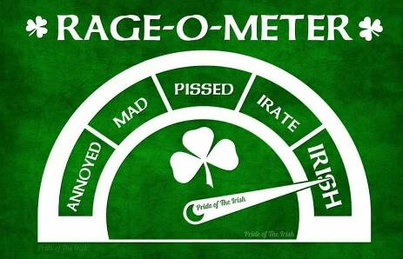

Irish Temper

Irish temper and rage are proverbial and cliché. ‘Irish temper’ at google gets 60,000 hits.
https://www.urbandictionary.com/define.php?term=Irish%20temper :
“The stereotypical temper of the Irish, and those of Irish descent. Most often somewhat unexpected, extremely passionate, and very short-lived.”
There are scores of pictures and t-shirts that deal with Irish rage, anger or temper. This ‘cliche’ clue of Dan, we find back among the Irish and not among the Danes from Denmark.

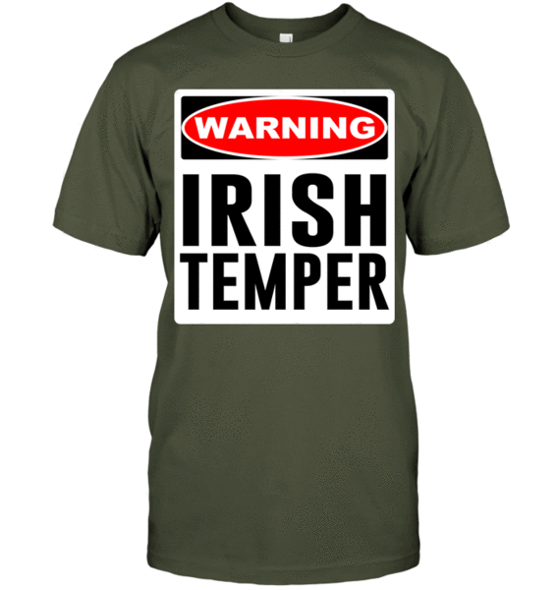

Irish Swearing

‘Irish swearing’ at Google gives 15,000 hits. There are sites with long lists of (funny) Irish curses and swearing. Tempers and cursing can be found back amongst all peoples. The Danites and the Irish are just a bit more known for it, than others.

4th Clue: Dan: humour, sarcasm, riddles

But if you can’t solve it, you will give me the same things." They responded, "Tell us your riddle! Let’s hear it!" So Samson said to them,
"From the eater came
something to eat.
From the strong one
came something sweet."
For three days they couldn’t solve the riddle (Judges 14:13-14, GWV).
So before sundown on the seventh day, the men of the city said to him,
"What is sweeter than honey?
What is stronger than a lion?"
Samson replied,
"If you hadn’t used my cow to plow,
you wouldn’t know my riddle now."
(Judges 14:18, GWV).
Samson found the jawbone from a donkey that had just died. He picked it up and killed 1,000 men with it. Then Samson said,
"With a jawbone from a donkey,
I’ve made two piles of them.
With a jawbone from a donkey,
I’ve killed a thousand men."
(Judges 15:15-16, GWV).

Her name was Delilah. The Philistine rulers came to her and said, "Trick him, and find out what makes him so strong. ... 7 Samson told her, "If someone ties me up with seven new bowstrings that are not dried out, I will be like any other man." ... 10 Delilah told Samson, "Look, you’re making fun of me by telling me lies. Now, tell me how you can be tied up." 11 Samson told her, "If someone ties me up tightly with new ropes that have never been used, I will be like any other man." ... 13 Delilah told Samson, "You’re still making fun of me by telling me lies. Tell me how you can be tied up." Samson replied, "Just weave the seven braids of my hair with the other threads in the loom." 14 So Delilah tied his braids to the loom shuttle. ... But Samson woke up and tore his braids and the threads out of the loom shuttle. 15 Delilah said to Samson, "How can you say that you love me ... You’ve made fun of me three times now, but you still haven’t told me what makes you so strong." (Jdgs 16).

Humour, sarcasm, riddles

Samson the Nazirite is the best known Danite of the Bible. He loved humour, sarcasm and riddles. His humour is often kind of black. Many of Samson’s actions are often comical, as if he wants to play a practical joke on people (see 5th clue).
There are also the 5 Danites, looking for new territory for their tribe. On their way north they stay with a certain Micha in the tribal area of Ephraim. With dark humor they thank him for his hospitality by robbing him of his priest, ephod and idols.
The Danites first conquered and burned Laish and then built it up again. With a kind of humour they named many topographical places Dan, Dun or Don.

Irish Humour: Craic

Wikipedia: “Craic or crack is a term for news, gossip, fun, entertainment, and enjoyable conversation, particularly prominent in Ireland. It is often used with the definite article – the craic – as in the expression "What's the craic?" (meaning "How are you?" or "What's happening?"). ... Under either spelling, the term has great cultural currency and significance in Ireland. ... Now, 'craic' is interpreted as a specifically and quintessentially Irish form of fun. ... "The craic" has become a part of Irish culture. In a 2001 review ... professor Eileen M. Trauth called "craic" an intrinsic part of the culture of sociability that distinguished the Irish workplace from those of other countries. Trauth wrote that even as Ireland transitioned away from a society dominated by agriculture, the traditional importance of atmosphere and the art of conversation – "craic" – remains, and that the social life is a fundamental part of workers' judgment of quality of life.”

Irish Comedians
https://ireland-calling.com/irish-comedians/ :
“Ireland and its people are renowned for enjoying a laugh and a good time. So it is not surprising that the country has produced so many top class comedians throughout the years. One-liners, storytelling, observational comedy, whacky characters and comical songs … Irish comedians are masters at it all. There is a great range of talents amongst the country’s funnymen and women and whatever your tastes, you are sure to find someone that will have you splitting your sides.”

5th Clue: Dan: practical jokes

And the Spirit of the LORD came upon him, and he went down to Ashkelon, AND SLEW THIRTY MEN OF THEM, AND TOOK THEIR SPOIL, AND GAVE CHANGE OF GARMENTS UNTO THEM WHICH EXPOUNDED THE RIDDLE. And his anger was kindled, and he went up to his father’s house (Jdgs 14:19).
And Samson went and caught 300 FOXES, AND TOOK FIREBRANDS, AND TURNED TAIL TO TAIL, AND PUT A FIREBRAND IN THE MIDST BETWEEN TWO TAILS. AND WHEN HE HAD SET THE BRANDS ON FIRE, HE LET THEM GO INTO THE STANDING CORN OF THE PHILISTINES, and burnt up both the shocks, and also the standing corn ... (Judges 14:4-5).
And he found a new jawbone of an ass, and put forth his hand, and took it, and slew a 1,000 men therewith. And Samson said, WITH THE JAWBONE OF AN ASS, HEAPS UPON HEAPS, WITH THE JAW OF AN ASS HAVE I SLAIN A 1,000 MEN (Jdgs 15:15-16).
And Samson lay till midnight, and arose at midnight, AND TOOK THE DOORS OF THE GATE OF THE CITY, AND THE TWO POSTS, AND WENT AWAY WITH THEM, BAR AND ALL, AND PUT THEM UPON HIS SHOULDERS, AND CARRIED THEM UP TO THE TOP OF AN HILL THAT IS BEFORE HEBRON (Judges 16:3).
If they bind me WITH 7 GREEN WITHS that were never dried, then shall I be weak ... If they bind me fast WITH NEW ROPES that never were occupied, then shall I be weak ... If thou WEAVEST THE 7 LOCKS OF MY HEAD WITH THE WEB ... (Judges 16).
Dictionary Internet: practical joke:

“a prank or trick played on a person (especially one intended to make the victim appear foolish)”.

Samson & Practical Jokes

It was not enough for Samson to beat his opponents by strength. He also used practical jokes to make fools of them. When he had to pay 30 cloaks to 30 Philistines, he just killed 30 other Philistines. He set fire to the Philistine corn with 300 foxes. He killed 1,000 Philistines with a fresh jawbone of a donkey, as if to say that they were donkeys. Escaping from Gaza was not enough, he ripped up the gate, doors and posts, and carried them to a hilltop. Three times he made fun of Delilah by giving her fake instructions. Even his death is a kind of practical joke. By having the temple collapse on him, he made a powerless fool of Dagon, the god of the Philistines.

Irish & Practical Jokes

Irish have quite a sense of humour and are especially fond of practical jokes. Many can be found on the internet. One of the most extreme pranks I found was by Shay Bradley.

Shay Bradley

https://mashable.com/article/irish-man-pranks-family-at-funeral/?europe=true :
“Funerals are some of the most heartbreaking experiences we go through as humans, but every so often we get a beautiful chance to merge the tragedy with a laughter that eases the tension. Shay Bradley of Kilnamanagh in the south of Dublin, Ireland, passed October 8, but that didn't mean he was ready to give up his life's passion of pranking his family. When his coffin was lowered and the bag pipes began playing, something unusual happened – an audio recording of his voice began playing. "Hello? Hello," starts Bradley's voice to everyone's astonishment. "Let me out, it’s dark in here!" Pretty quickly the crowd's tears turn to laughter as the recording mimics Bradley knocking on the wooden coffin. Bradley's daughter, Andrea Bradley, posted the video to Facebook. "My dad's [dying] wish, always the pranksters, ya got them good Poppabear, and gave us all a laugh just when we needed it!! I will love you forever.He would love to know how many people he made laugh!!! He was an amazing character," Andrea wrote on Twitter. At the end of the video, you can hear Bradley serenading his loving family one last time.”
6th Clue: Dan: Irish & the Sea

... AND WHY DID DAN REMAIN IN SHIPS? ... (Judges 5:17).
And the seventh lot came out for the tribe of the children of Dan according to their families. AND THE COAST OF THEIR INHERITANCE WAS Zorah, Eshtaol, Irshemesh, Shaalabbin, AJALON, Jethlah, Elon, Thimnathah, Ekron, Eltekeh, Gibbethon, Baalath, Jehud, BENEBERAK, Gathrimmon, Mejarkon, and Rakkon, WITH THE BORDER BEFORE JAPHO [present-day Jaffa and Tel Aviv] (Joshua 19:40-46).

Deborah’s Song

In Deborah’s Song many tribes are accused of not turning up, when they had to, when the northern tribes fought Sisera.
The tribe of Dan is accused of preoccupation with their ships. At the time the Danites still lived at their original tribal area between Judah and the sea, at present-day Jaffa and Tel Aviv. At the time they had not conquered Leshem in the north yet.
Jaffa, of Yafo, was one of the few ports of Israel and it was in Danite hands. Through this port they had a lot of contact with the Phoenicians. According to the Jewish Encyclopedia Danites had joined Phoenician ships (see Jewish Encyclopedia, Tribe of Dan).

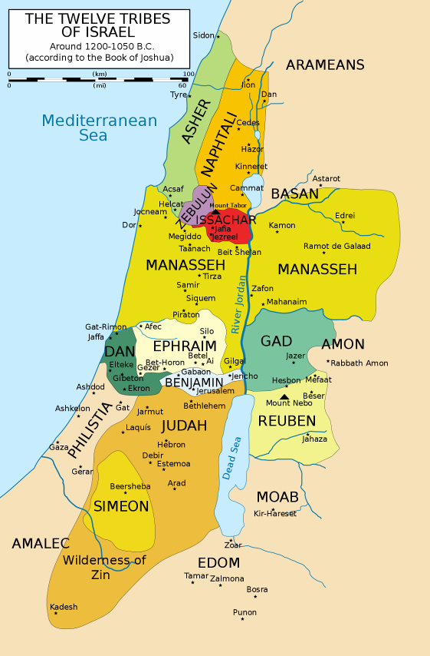
Tribal area of Dan at Jaffa, at the sea
Irish & the Sea

https://aoh.com/2008/09/01/the-seafaring-irish/
The Seafaring Irish, September 1, 2008 By Mike McCormack. “Ireland has the largest percentage of coastline in Europe, in fact, there are few spots in Ireland more than 70 miles from water ... The fact is that the early Irish were a seafaring race ... That the early Irish were no strangers to the sea is revealed in her ancient manuscripts ... Ireland’s settlers came across the seas; from the Fir Bolg, who escaped bondage in Greece in boats made of wood and leather, to the Celts of Iberia, who came in a fleet of ships with which they traded along the coast of Europe ... Irish Sail the World. Their seafaring ability brought Celtic sailors to America long before the time of Christ as described in the book America BC by the late Dr. Barry Fell ... In the ensuing centuries, seafaring remained a component part of Irish life in both trade and warfare. However, since the structure of Irish civilization was a collection of independent clans rather than a nation, there was no national navy. In spite of that fact, Irish sea-raiders remained the most feared pirates along the coast of western Europe. It was on one of these raids that High King Niall ... took the boy Patrick as a slave. Patrick’s return to Ireland and subsequent conversion of the Irish to Christianity condemned piracy as an occupation, but it did not eliminate the sailing ability of the Irish. Instead, this now largely religious population took to the sea as missionary monks to spread the nets for God. They ... followed their ancestors across the Atlantic to North America. Not only did St. Brendan write of sailing to America, but the history of Iceland records the visits of Irish monks to their shores long before the Vikings ...”

Irish & the Navy

Many Irish served in the British and US navies:
https://en.wikipedia.org/wiki/Category:Irish_sailors_in_the_Royal_Navy &

Curragh
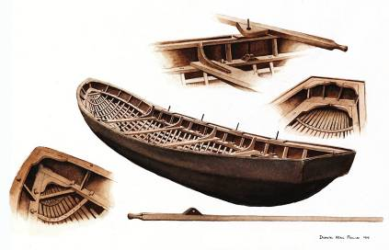
A curragh or currach is a cano-like boat used in the past by Irish monks for long journeys across the north of the Atlantic Oceon.
7th Clue: Dan: lying & fantasy

If they bind me WITH SEVEN GREEN WITHS THAT WERE NEVER DRIED, then shall I be weak ... And Delilah said ... Behold, THOU HAST MOCKED ME, AND TOLD ME LIES: now tell me ... wherewith thou mightest be bound. And he said ... If they bind me fast WITH NEW ROPES THAT NEVER WERE OCCUPIED, then shall I be weak ... And Delilah said ... THOU HAST MOCKED ME, AND TOLD ME LIES: tell me wherewith thou mightest be bound. And he said unto her, If thou weavest THE SEVEN LOCKS OF MY HEAD WITH THE WEB. ... And she said unto him, How canst thou say, I love thee, when thine heart is not with me? THOU HAST MOCKED ME THESE THREE TIMES, and hast not told me wherein thy great strength lieth (Judges 16).
[Testament of Dan, also called Testament of Anger & Lying]: The copy of the words of Dan, which he spake to his sons in his last days, ... that TRUTH with just dealing is good and well pleasing to God, and that LYING and anger are evil ... that unless ye keep yourselves from THE SPIRIT OF LYING and of anger ... ye shall perish ... and through LYING darkeneth his mind, and giveth him its own peculiar vision. ... This spirit [of anger] goeth always WITH LYING at the right hand of Satan, that with cruelty and LYING his works may be wrought. ... for from vexation ariseth wrath WITH LYING. Moreover, a twofold mischief is wrath WITH LYING; and they assist one another in order to disturb the heart ... And keep His law; Depart from wrath, AND HATE LYING, ... (Testament of Dan).

Dan & lying

According to the Testament of Zebulun it was Dan who came up with the idea of dipping Joseph’s coat of many colours into blood: “Dan therefore came to him and said: Weep not, neither grieve; for we have found what we can say to our father Jacob. Let us slay a kid of the goats, and dip in it the coat of Joseph; and let us send it to Jacob, saying: Know, is this the coat of thy son? And they did so. ... and they did even as Dan had said.”(Test. of Zebulun).
The Testament of Dan has as subtitle: Dan’s speech about the evil of anger and lying.

Internet about Irish lying

https://entertainment.ie/trending/new-survey-reveals-that-irish-people-tell-an-average-of-four-white-lies-per-day-339268/ :
“We're nothing but a bunch of filthy, horrible liars.
Ireland has a problem with telling the truth, as a new survey revealed our love for an occasional fib and the odd absolute whopper and/or stonker of a lie, and exactly where we're bending the truth to fit our needs.
It turns out that we tell an average of four white lies a day, while 10% of people admitted that they would tell 10 or more white lies on any given day. For the guys out there, the main topics that they lied about were their sporting prowess, (32%) of those surveyed admitted to making false claims about their athleticism), their salary (21%), having an ability to cook (20%) and having read impressive or high brow books (19%).”

https://www.her.ie/life/14-lies-you-believed-as-an-irish-child-224924

On this site 14 lies are dished up that Irish mothers tell: My favourite one: Irish mother: “Watching food cook in the microwave will give you radiation poisoning!” Whatever magical futuristic beams made your popcorn pop would simultaneously fry your brain/eyesight/senses if you looked directly at them? We still squint through the door in anticipation of disaster.”

Lying & fantasy

Mythology is often made up of fantastic stories, legends and sagas, which are in fact a kind of ‘lie’. Irish mythology and old Irish history often are a range of contrasting stories.

Leprechaun, banshee, aspidochelone, etc.

Wikipedia: “A leprechaun is a type of fairy of the Aos Sí in Irish folklore. They are usually depicted as little bearded men, wearing a coat and hat, who partake in mischief. They are solitary creatures who spend their time making and mending shoes ... Leprechaun-like creatures rarely appear in Irish mythology and only became prominent in later folklore.”
Then there are other fantastic beings like the aspidochelone and the banshee.

Irish Literature

All that fantasy has led to an important Irish literature. For a relative small island, Ireland has contributed substantially to world literature. After Greek and Latin literature, it is the third oldest of Europe. Ireland has produced four Noble Prize winners for Literature, William Butler Yeats, George Bernard Shaw, Samuel Beckett and Seamus Heaney.
8th Clue: Dan: weakness for women

And Samson went down to Timnath, AND SAW A WOMAN in Timnath OF THE DAUGHTERS OF THE PHILISTINES. And he came up, and told his father and his mother, and said, I HAVE SEEN A WOMAN in Timnath OF THE DAUGHTERS OF THE PHILISTINES: now therefore get her for me to wife. Then [they] said unto him, IS THERE NEVER A WOMAN AMONG THE DAUGHTERS OF THY BRETHREN, or among all my people, that thou goest to TAKE A WIFE OF THE UNCIRCUMCISED Philistines? And Samson said unto his father, GET HER FOR ME; FOR SHE PLEASETH ME WELL (Judges 14:1-3)
Then went Samson to GAZA, AND SAW THERE AN HARLOT, and WENT IN UNTO HER. ... And they compassed him in, and laid wait for him all night in the gate of the city ... And Samson lay till midnight, and arose at midnight ... (Judges 16:1-3).
4 And it came to pass afterward, THAT HE LOVED A WOMAN IN THE VALLEY OF SOREK, whose name was DELILAH. 5 And the lords of the Philistines came up unto her, and said unto her, ENTICE HIM, and see wherein his great strength lieth ... 16 And it came to pass, when she pressed him daily with her words, and urged him, so that his soul was vexed unto death; 17 THAT HE TOLD HER ALL HIS HEART, and said unto her, There hath not come a razor upon mine head; for I have been a Nazarite ... 19 AND SHE MADE HIM SLEEP UPON HER KNEES; and she called for a man, and she caused him to shave off the seven locks of his head ... But the Philistines took him, and put out his eyes, and brought him down to Gaza ... (Judges 16).

Philistine women

The Danite Samson had a weakness for women. First he married a Philistine woman from Timnath, also situated upon the brook Sorek. Secondly he visited a harlot in the Philistine town of Gaza. And thirdly we read about the worldfamous story of Samson & Delilah. He started living with her in the valley of Sorek. Consequently she seduced and betrayed him.

Drinking & Wenching

The Irish folkband The Dubliners released an album in 1976 called Drinking and Wenching (1976). On it are many songs about ‘wenching’.
https://www.thefreedictionary.com/wenching :

intr.v. wenched, wench·ing, wench·es
To consort with promiscuous women. Used of a man.

Of course all peoples have promiscuous men and women. Whether Irish men are more often womanizers than others, I do not know, but they do sing more about it than others.

Magdelena Laundries

Wenching may sound cute in songs, but in a catholic country like Ireland contraceptives were forbidden. Pregnant women often ended up in Magdalene laundries:

https://en.wikipedia.org/wiki/Magdalene_Laundries_in_Ireland :
“The Magdalene Laundries in Ireland, also known as Magdalene asylums, were institutions usually run by Roman Catholic orders, which operated from the 18th to the late 20th centuries. They were run ostensibly to house "fallen women", an estimated 30,000 of whom were confined in these institutions in Ireland. In 1993, a mass grave containing 155 corpses was uncovered in the convent grounds of one of the laundries. This led to media revelations about the operations of the secretive institutions.“

Wenching on the one side and abortion being forbidden on the other side, once led to 7,000 abortions abroad for 58,000 live births.

John F. Kennedy



John F. Kennedy was the first catholic American president. The Kennedy’s were originally from Ireland. John Kennedy and his father Joe were infamous womanizers. JFK is said to have said: “If I don't have sex every day, I get a headache.’ Sexual escapades of three Kennedy generations can be found on the internet.
9th Clue: Dan: Celtic Craft

And the LORD spake unto Moses, saying, 2 See, I have called by name BEZALEEL the son of Uri, the son of Hur, OF THE TRIBE OF JUDAH: 3 And I have filled him with the spirit of God, in wisdom, and in understanding, and in knowledge, and in all manner of WORKMANSHIP, 4 To devise cunning works, TO WORK IN GOLD, AND IN SILVER, AND IN BRASS, 5 And in cutting of stones, to set them, and in carving of timber, to work in all manner of WORKMANSHIP. 6 And I, behold, I have given with him AHOLIAB, the son of Ahisamach, OF THE TRIBE OF DAN: ... that they may make all that I have commanded thee; 7 The tabernacle of the congregation, and the ark of the testimony, and the mercy seat that is thereupon, and all the furniture of the tabernacle, 8 And the table and his furniture, and the pure candlestick with all his furniture, and the altar of incense ... (Ex 31:1-9).
And he hath put in his heart that he [BEZALEEL] may teach, both he, and AHOLIAB, the son of Ahisamach, OF THE TRIBE OF DAN (Ex 35:34).
And with him [BEZALEEL] was AHOLIAB, son of Ahisamach, OF THE TRIBE OF DAN, AN ENGRAVER, AND A CUNNING WORKMAN, ... (Ex 38:23).
And now I have sent a cunning man, endued with understanding, of HURAM my father’s, THE SON OF A WOMAN OF THE DAUGHTERS OF DAN, and his father was a man of Tyre, SKILFUL TO WORK IN GOLD, AND IN SILVER, IN BRASS, IN IRON, in stone, and in timber, in purple, in blue, and in fine linen, and in crimson; ALSO TO GRAVE ANY MANNER OF GRAVING, and to find out every device which shall be put to him, ... (2Chron 2:13-14).
... And HURAM MADE THE POTS, AND THE SHOVELS, AND THE BASONS. And Huram finished the work that he was to make for king Solomon for the house of God ... (2Chron 4:11).

Two Danites were involved in making objects for the tabernacle and for Solomon’s temple. They were accomplished gold/silver smiths. So were the Celts in Ireland.

National Museum of Archeology

Wikipedia: “Ór - Ireland’s Gold, The central area of the museum contains one of the finest collections of Bronze Age gold objects in Europe. ... most of it probably being jewellery, but with many objects of unknown (possibly ritual) function. In the early Bronze Age most artefacts were made from sheet gold and include sundiscs and crescent shaped collars called lunulae. In the middle Bronze Age new gold working techniques were developed; ... a great variety of torcs were produced from twisting bars of gold. Items from the late Bronze Age, starting in 900 BC, include solid gold bracelets and dress-fasteners as well as large sheet gold collars, ear-spools and a necklace of hollow golden balls.”

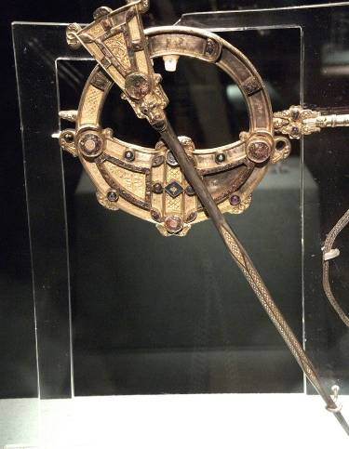
The Tara Brooch

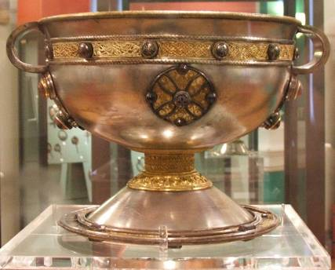
The Ardagh Chalice

Wikipedia: “The chalice ranks with the Book of Kells as one of the finest known works of Insular art, indeed of Celtic art in general, and is thought to have been made in the 8th century AD.”

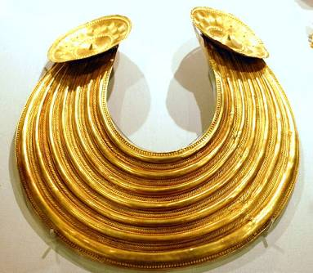
The Gleninsheen gold collar
10th Clue: Dan & the House of David

For thus saith the LORD; David shall never want a man to sit upon the throne of the house of Israel ... And the word of the LORD came unto Jeremiah, saying, Thus saith the LORD; If ye can break my covenant of the day, and my covenant of the night, and that there should not be day and night in their season; Then may also my covenant be broken with David my servant, that he should not have a son to reign upon his throne ... As the host of heaven cannot be numbered, neither the sand of the sea measured: so will I multiply the seed of David my servant ... Moreover the word of the LORD came to Jeremiah, saying ... If my covenant be not with day and night, and if I have not appointed the ordinances of heaven and earth; Then will I cast away the seed of Jacob, and David my servant, so that I will not take any of his seed to be rulers over the seed of Abraham, Isaac, and Jacob: for I will cause their captivity to return, and have mercy on them (Jeremiah 33:17-26).

European Royal Houses

The last 250 years many empires, kingdoms and principalities have disappeared. Is it just a coincidence that the Lost Tribes nations of north-westeren Europe have kept their constitional monarchies? It is most likely no coincidence and it is very likely a sign that the House of David is still governing part of the House of Israel in north-western Europe.
To my understanding the follwing nations are Lost Tribes nations. With royalty: Norway, Sweden, Denmark, Benelux, United Kingdom. The latter with the Common Wealth Nations: Canada, New Zealand and (white) South Africans. Also the republics: Iceland, France, Switzerland, Ireland and the USA.

David – Zedekiah (450 years)

King David and his descendants ruled for about 450 years (ca. 1040-586 BC) in the Kingdom of Judah, 19 generations.

Daughters of Zedekiah

According to the British Israelite Movement Jeremiah and Baruch brought a daughter of king Zedekiah from Egypt to Ireland, where she married the local king. From then onwards the descendants of David ruled over the tribe of Dan. Zedekiah’s daughters had been taken to Egypt: “But Johanan ... took all the remnant of Judah ... Even men, and women, and children, and the king’s daughters ... and Jeremiah the prophet, and Baruch ... So they came to Egypt ... (Jer 43:5-7).”

Legend

Revd. F.R.A. Glover, M.A., from London, published in 1861 England, The Remnant of Judah, and the Israël of Ephraim, in which he introduced a daughter of Zedekiah (Tea Tephi) who had come from the east to Ireland to marry the king of Ireland, according to Irish mythology. If true, than this connects the House of David with the Irish, Scottish and English royal houses. If a daughter of king Zedekiah married an Irish king, then descendants of the House of David ruled over (parts of) the Lost Tribes, over the past 2500 years, like it was prophesied in Jeremiah 33.

James VI / James I

Elizabeth I had no children. After her death in 1603 the crown went to the Scottish James VI, who became England’s James I. James VI / I was a descendant of the Irish kings. All present-day royal houses of Europe descend from this king James I of England.

Monarchies and Republics

Glover wrote about his findings in 1861. In those days most countries were governed by dukes, princes, kings and emperors. In other words: a descendant of David could be ruling over Israelites anywhere on the globe. Take Ethiopia, descendants of Solomon (through Menelik I, son of Solomon and the queen of Sheba) were ruling over the falasha’s, black Jews. It could be argued that the Ethiopian emperors were fulfilling Jeremiah 33.

Monarchies disappear

It is noteworthy that Glover stated in 1861 that the royal houses in Europe descended of the House of David ... and that these royal houses only remained in north-western Europe and that most other governing monarchs disappeared. The world turned republic! Except in north-western Europe, where we find the Lost Tribes. Ireland has been an important link in that chain. For quite a while the House of David ruled over the tribe of Dan in Ireland.
It is interesting that the only mention of the House of David in ancient archeology is found on the Tel Dan Stele, found in Dan.
Bert Otten
Gouda, Holland

